Section1)  **create a internal javascript**

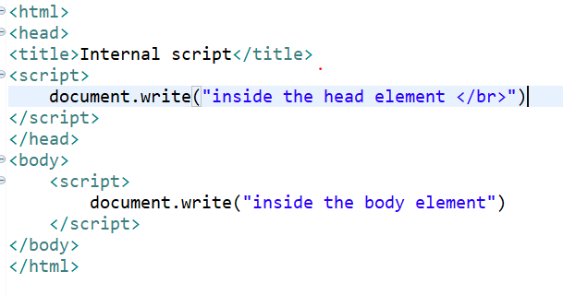

//output

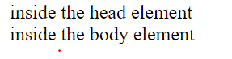

NOTE: document represent current html page

1. **create a external java script**

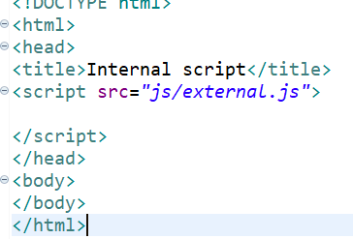

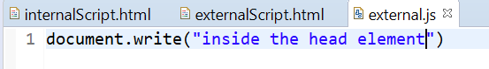

**Section 2**

1. **Js variables**

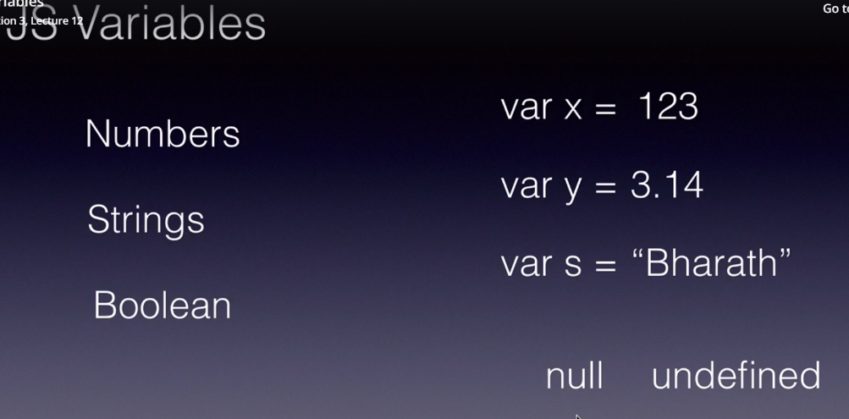

**Naming convention:-**

Variable name can start with _ or alphabet.

It cannot start with number

Note: javascript variables are case sensitive

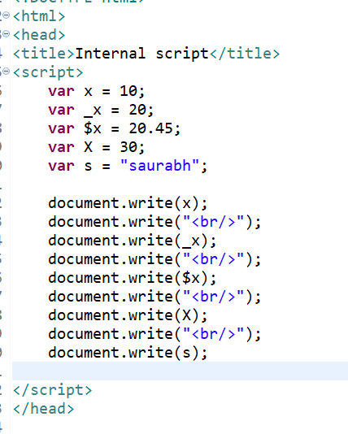

**Arithmetic operator**

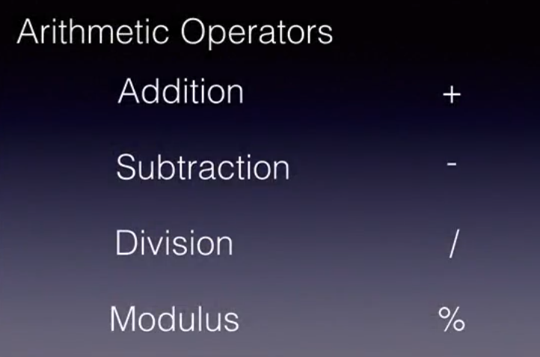

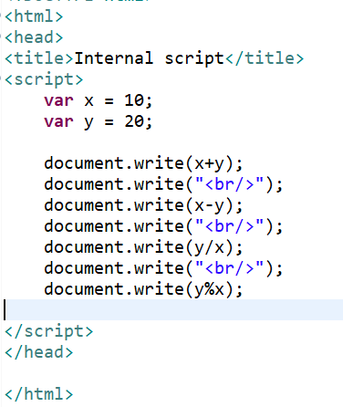

**//output**

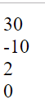

**Plus operator and string**

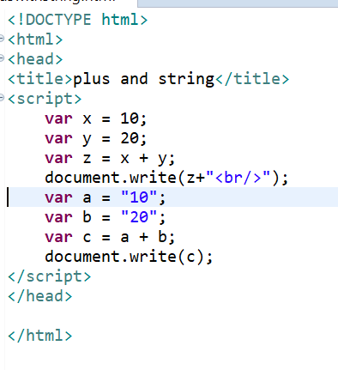

**//output:-**

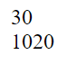

**NaN**

Javascript internally do typecasting

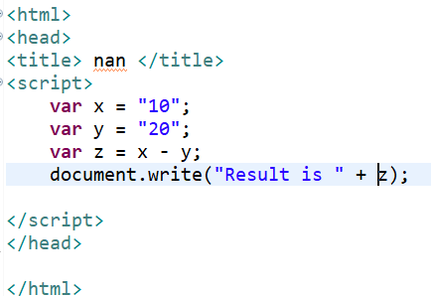

Output:-

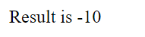

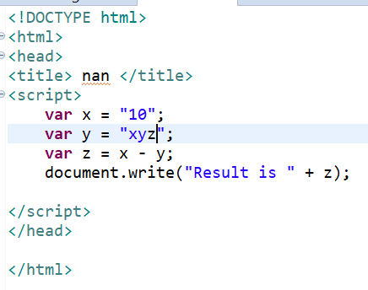

//output

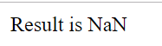

**Increment and decrement operator**

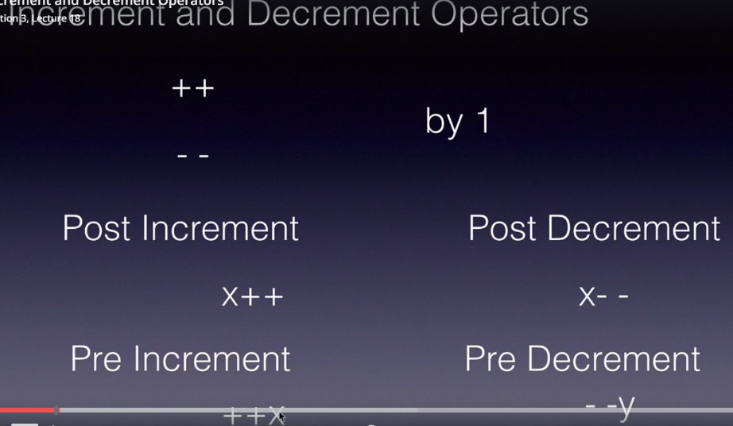

**Post increment:** first evaluation of expression will happen then ++ or -- evaluate

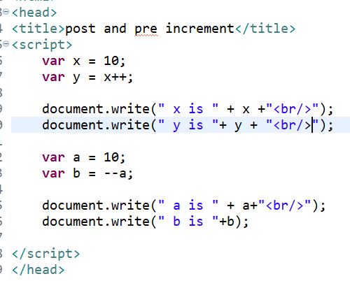

//output

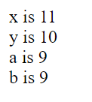

**Conditional Operator**

**=== check for types**

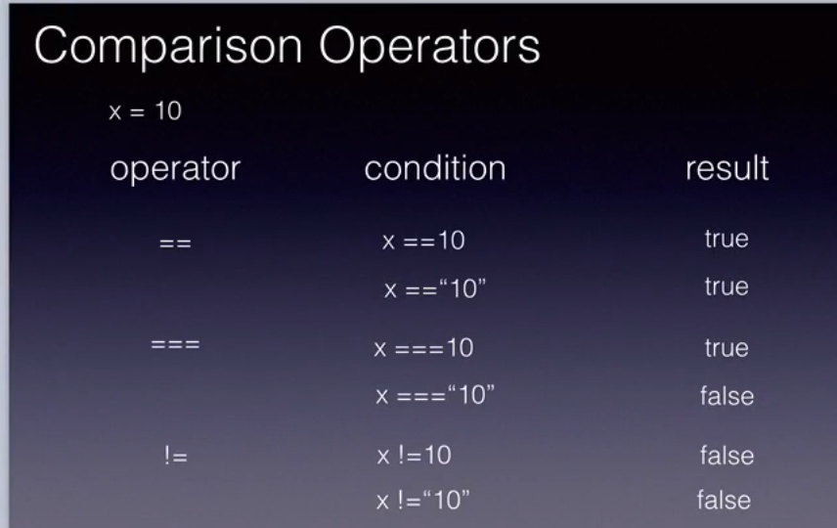

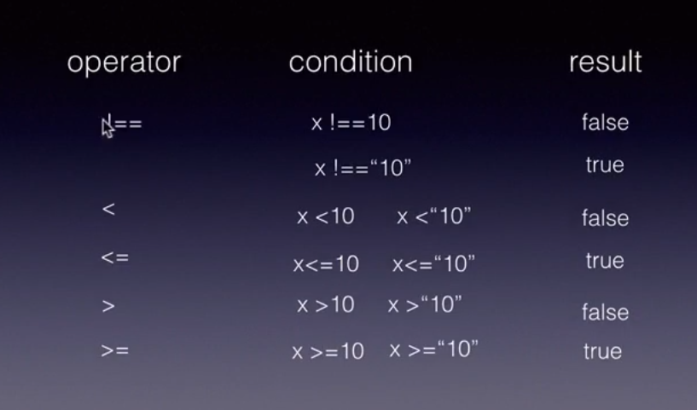

**Section -3 popup boxes**

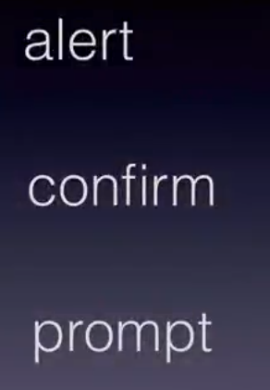

**Alert has one button while confirm has two**

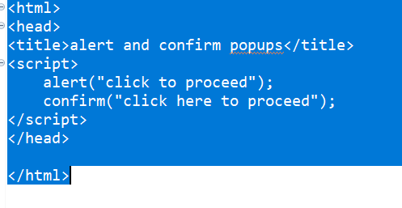

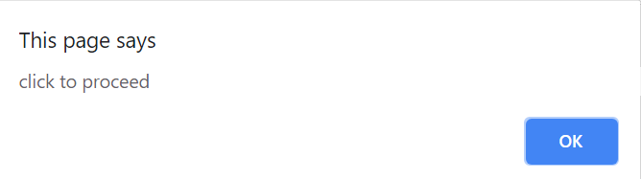

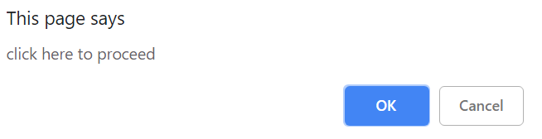

**Prompt:**

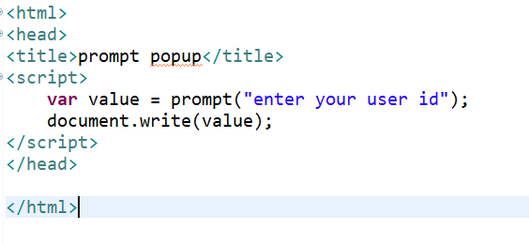

**Output:-**

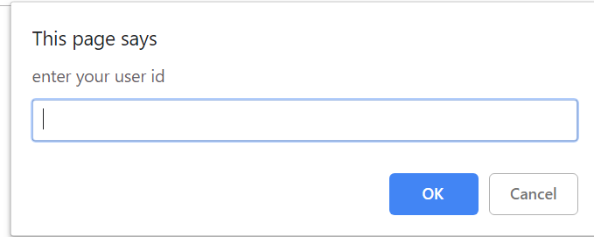

**Note: by default prompt take string value**

**Sum of two number using prompt**

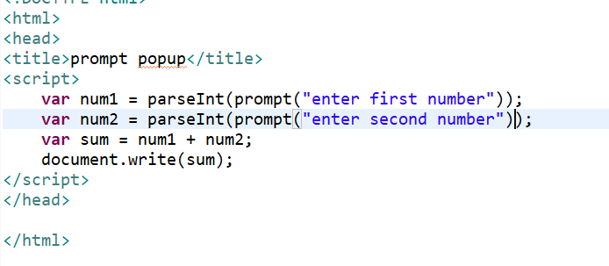

**Section 4)**

1. **If**

the body is executed only when condition is true

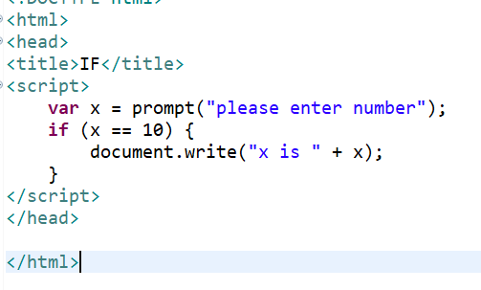

NOTE:

We can also pass default value to prompt

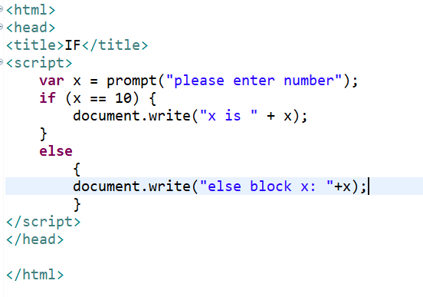

**If-else ladder**

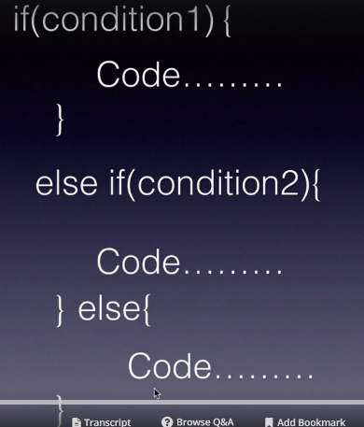

**Requirement**

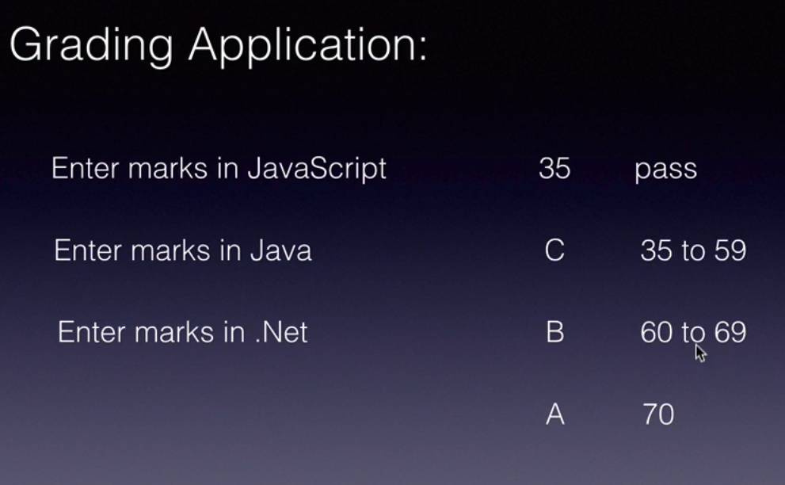

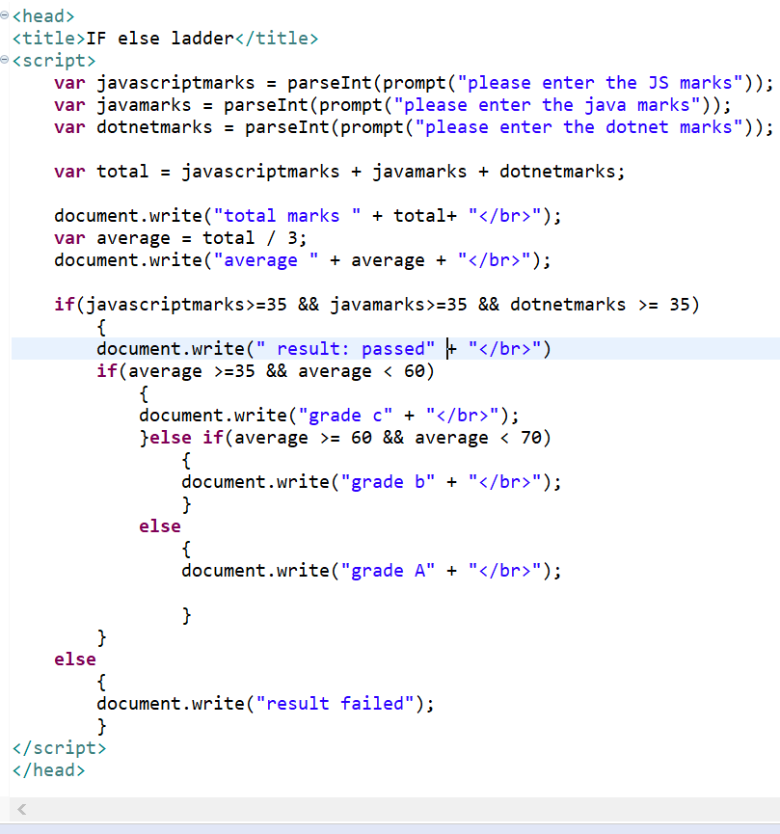

**Logical operator**

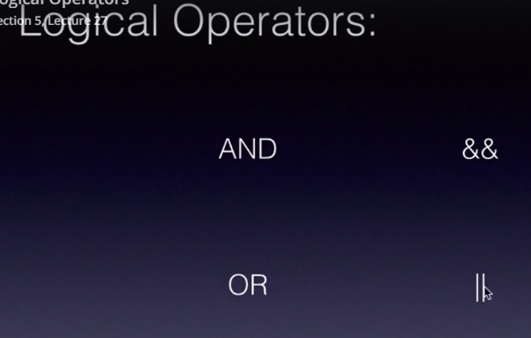

**Switch**

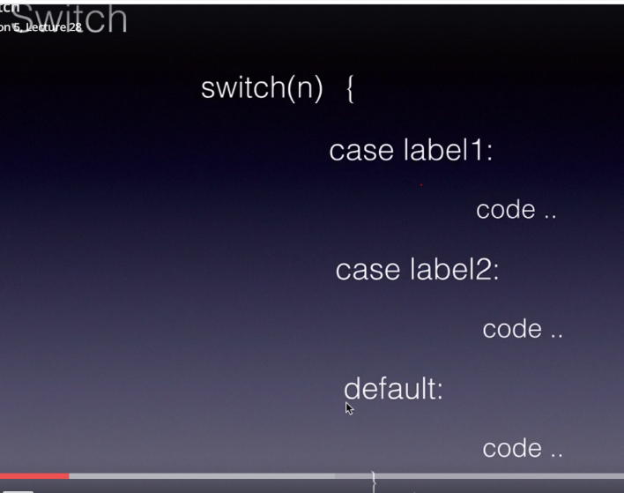

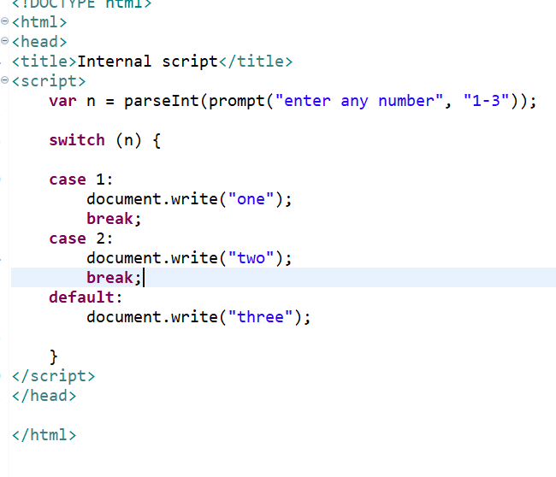

**Switch with string**

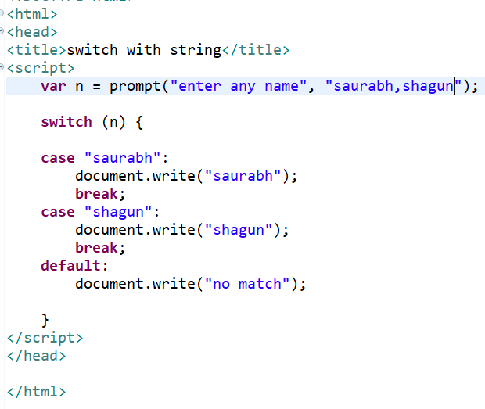

**Section 5 : loops**

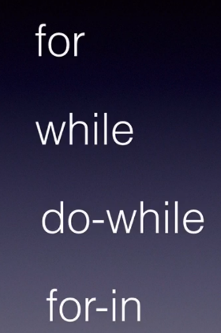

For-in loop is used to display property of JavaScript object

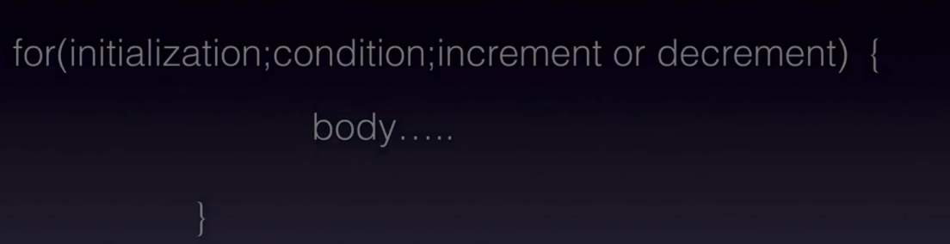

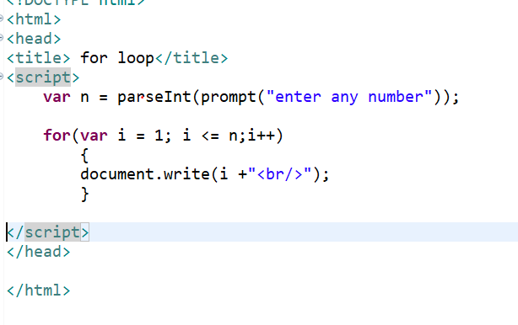

**While**

**Initialization happen before while and condition in while loop and increment /decrement inside while loop**

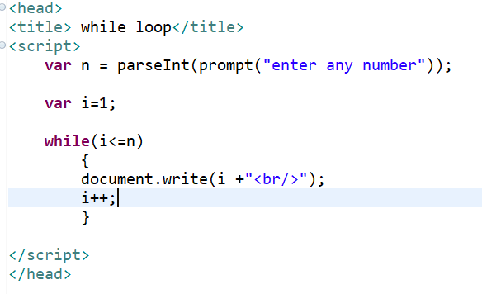

**Output:**

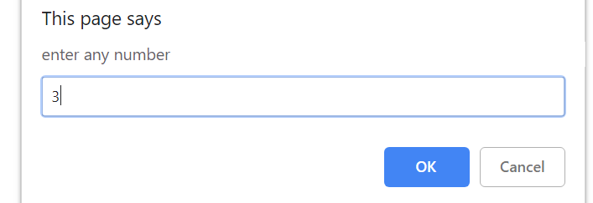

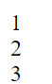

**Do-while**

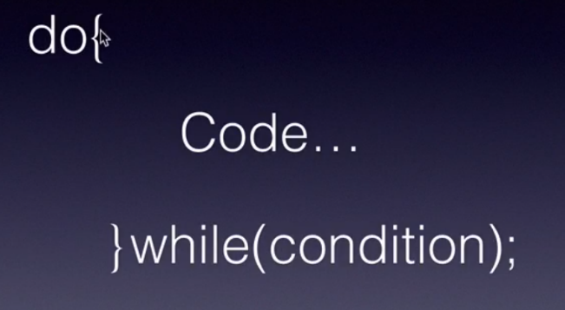

**Loop execute atleast once**

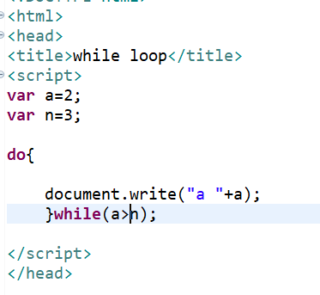

**Break and continue:-**

**Will use inside a loop conditionally**

**a)break : it will come out of loop**

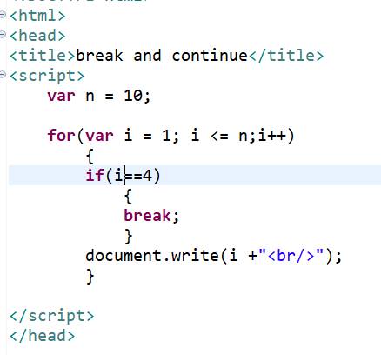

**//output:**

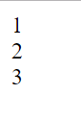

**b)continue**

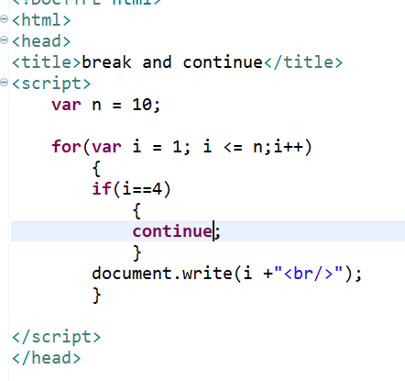

**Output**

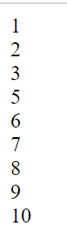

**Section : 6 function**

1. **User defined function**

**If we want to reuse a piece of code or logic then we defined inside function**

**We can assign function to browser event and Function will invoke whenever event occur**

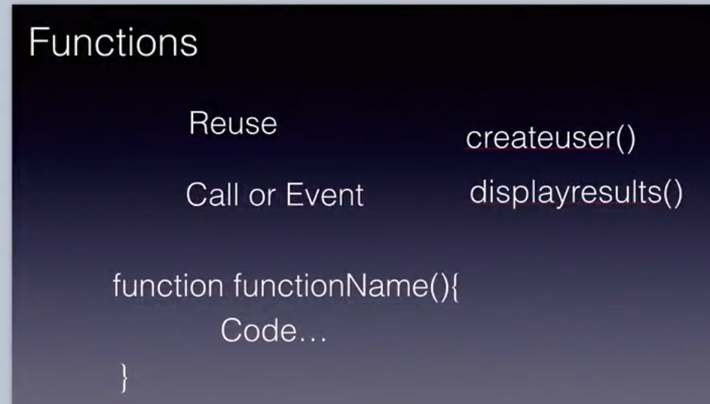

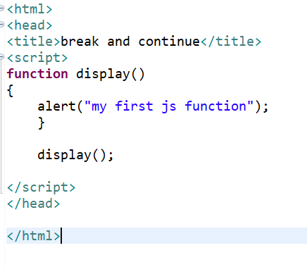

**Function with arguments**

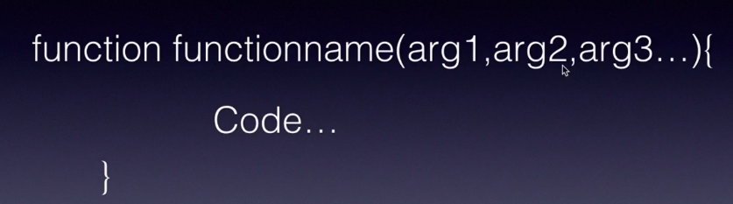

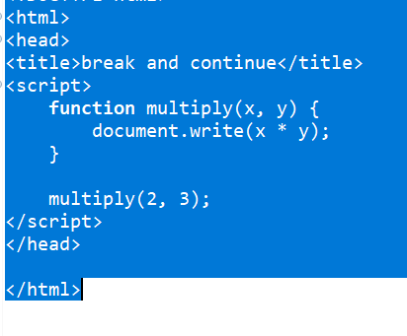

**Returning values from function**

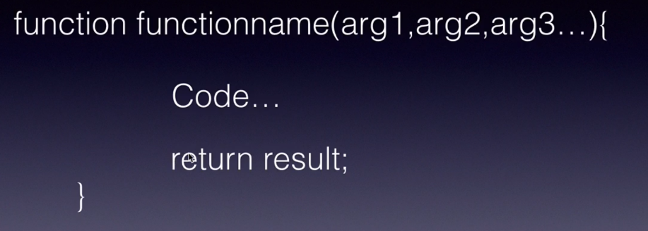

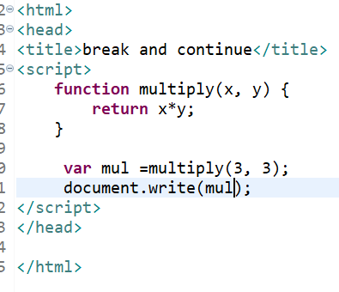

**Closures**

**Closures are function that we define inside other function. These function have access to parent function variables as well as global variable and local variable also.**

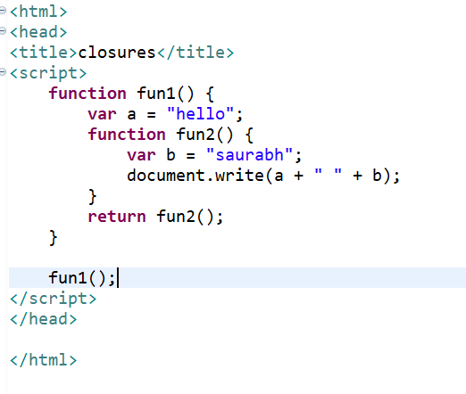

**Local and global variables:**

**Local variable are those which are available inside a function while global variable are those which are defined outside a function within a script block and can be used anywhere**

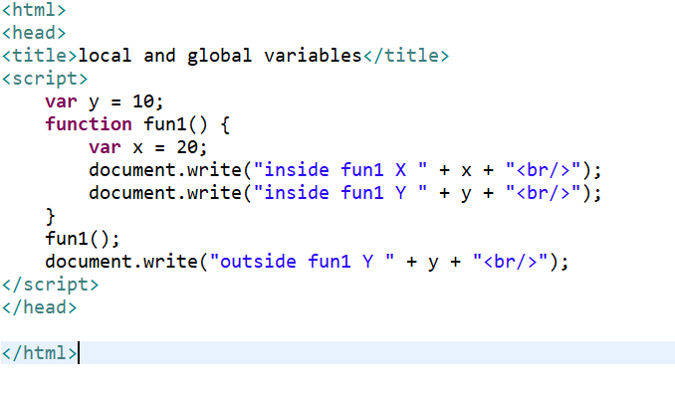

**Section 7: events**

**Event introduction**

**Note: event raised by browser itself or many times by user**

**Example:**

**Onload event** is fired by web browser once the html document is completely loaded into the browser

**Onfocus** is fired when user focuses on any text field, text area or any other html field

**Onclick** is fired by browser when user click on button

**Note:**- we as a developer handle these event

**Mouse over and mouse out event**

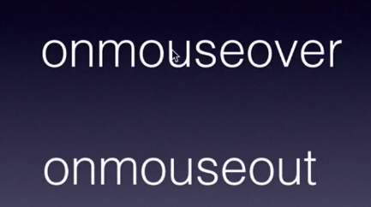

**Onmouseover event is triggered by browser** when user places a cursor on target element

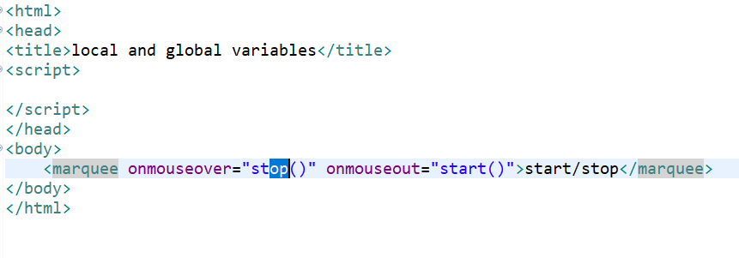

Stop() and start() is inbuilt function

**Using user defined function to handle events**

**This** point to current element (html) object and we can pass this inside a function

NOTE: we can also change content of html element inside function using innerHTML

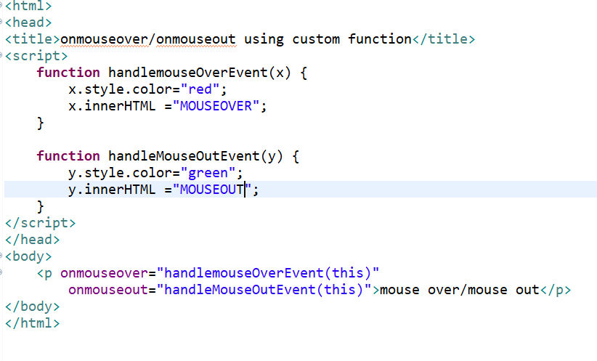

**Onclick event**

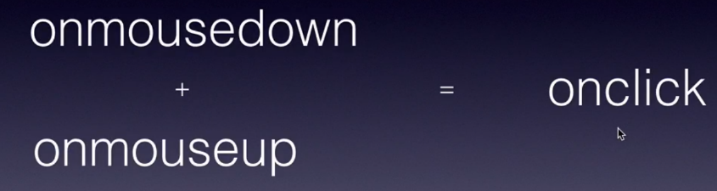

**How to retrieve html form field value within a java script function**

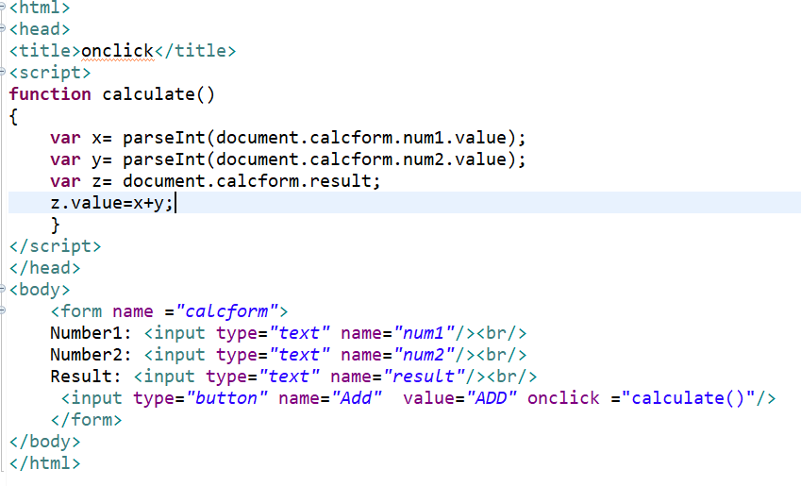

**//output**

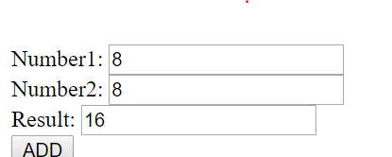

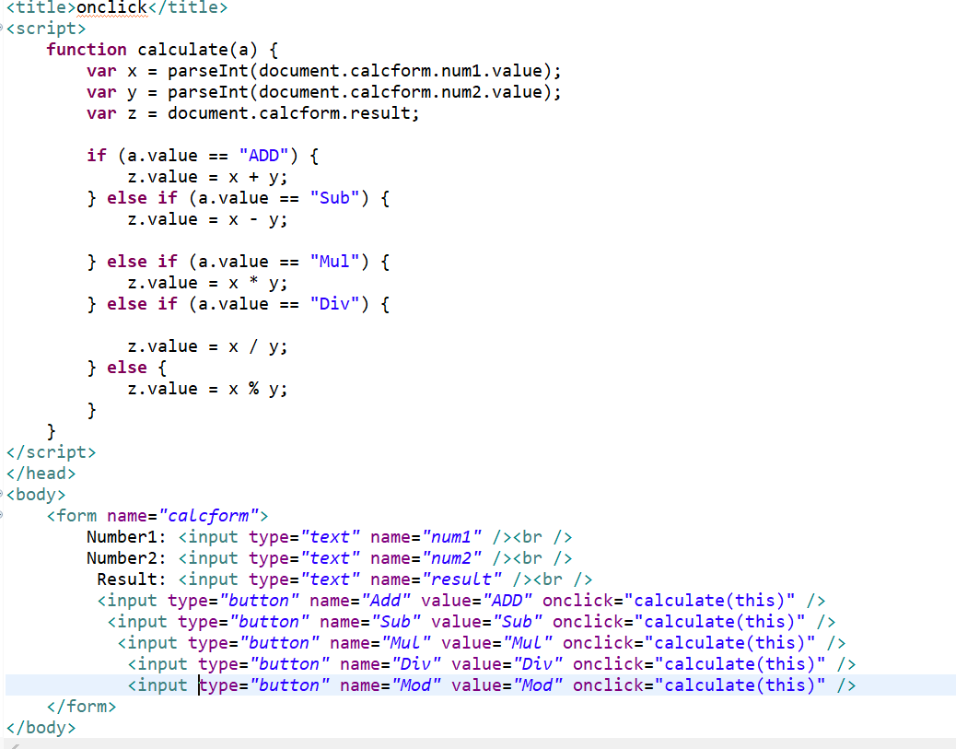

//output

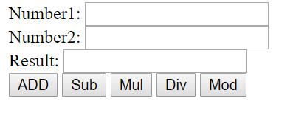

**Onchange switch background color**

**Onchange event triggered when change occur. Usually it occur with select box**

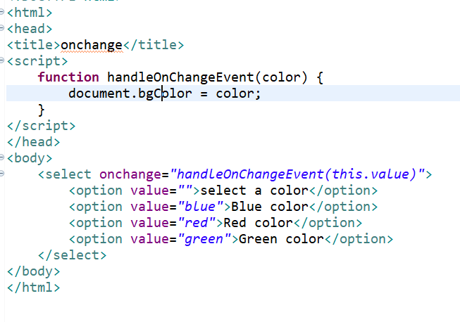

**//output**

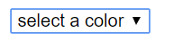

**Note window point to browser**

**Onchange switch website**

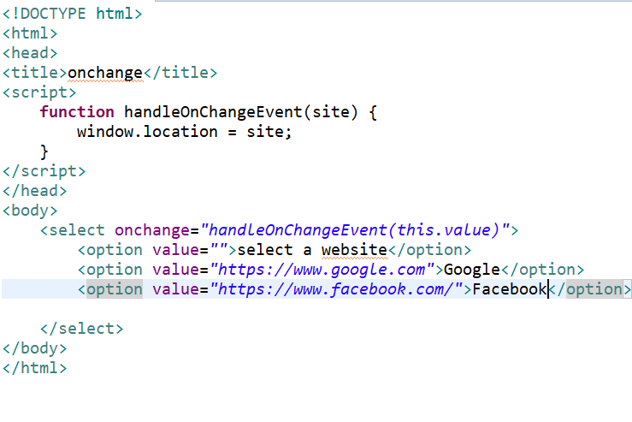

**switch background images**

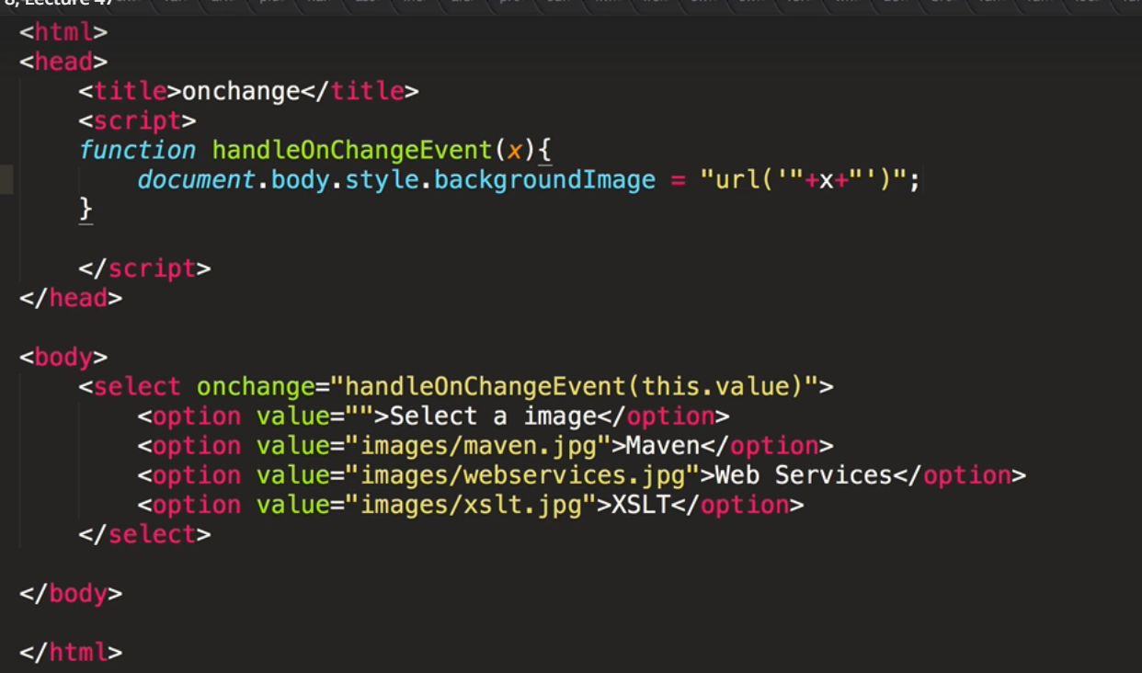

**Onfocus and onblur**

**Onfocus event is triggered by web browser when user places cursor on text field**

**While onblur event is triggered where user move cursor away from text field**

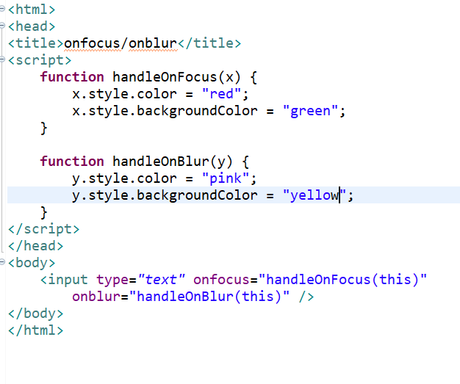

**==================================================================**

**JavaScript** - **Document** Object Model or DOM. Every web page resides inside a browser window which can be considered as an object. ... **Document**object − Each HTML **document** that gets loaded into a window becomes a **document** object. The**document** contains the contents of the page.

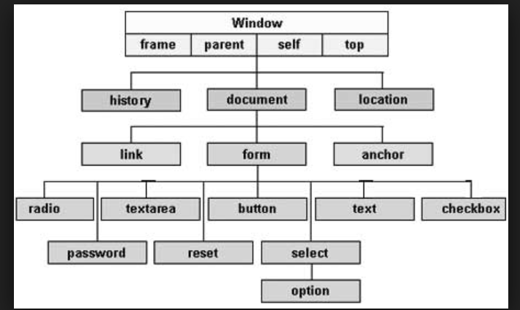

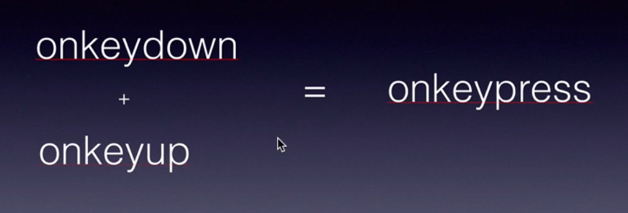

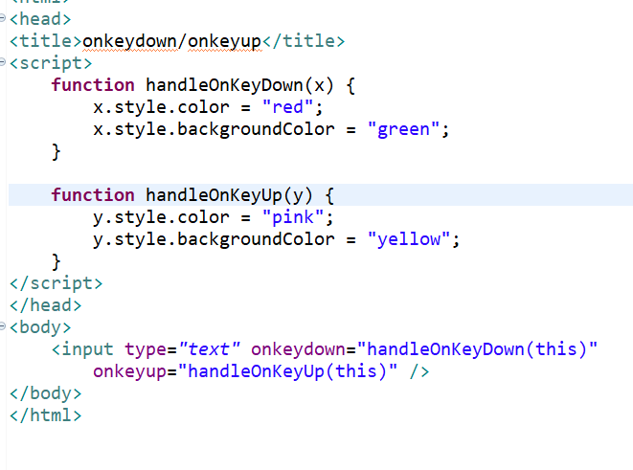

**Onload print:**

**Onload event is triggered when compete html document loaded into browser**

**Note: Onload goes to body tag**

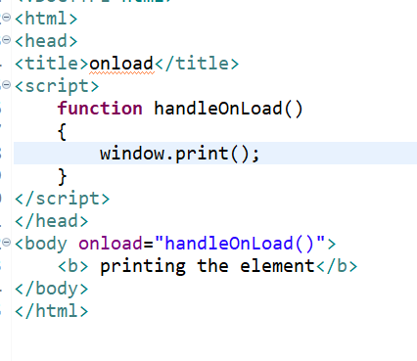

**Onload redirect**

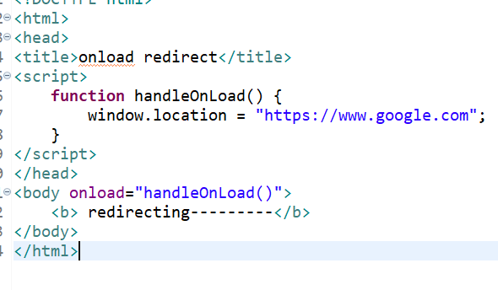

**setTimeOut**

**How to add a delay before particular java script function is invoked**

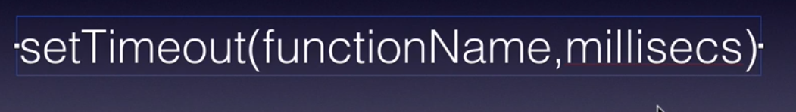

**Note: after 3 second google will open**

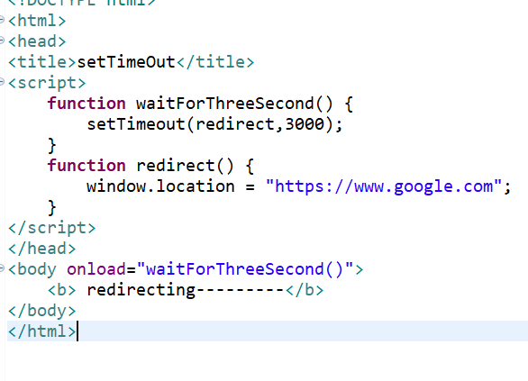

**onSubmit event**

**This event is triggered when user click submit button inside a html form**

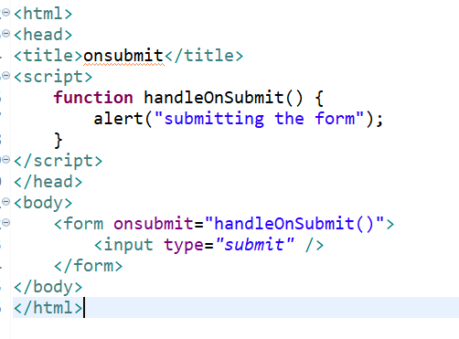

**//output:**

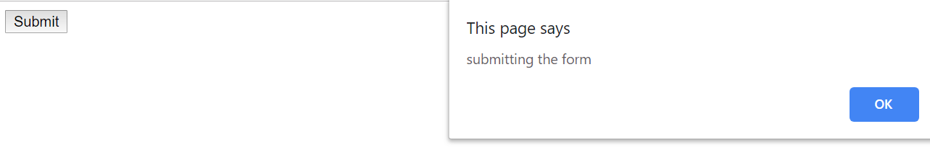

**Section 8) in built object**

**Strings**

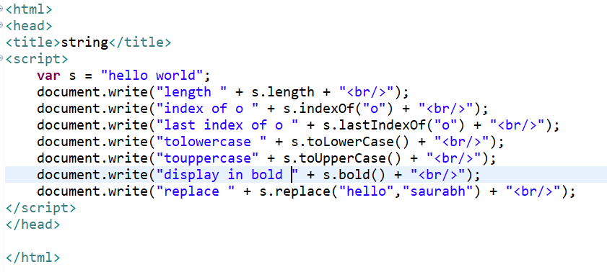

**//output**

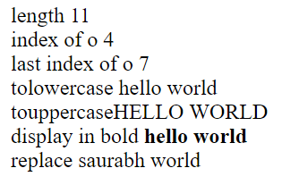

**Boolean**

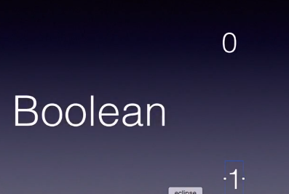

**0 represent false and 1 represent true**

**Empty string return false while non empty string will return true**

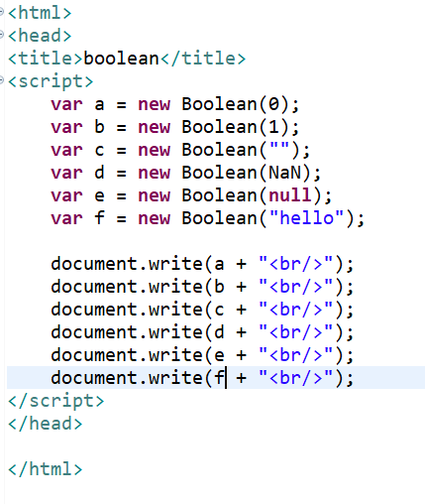

**//output**

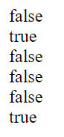

**Math**

**Floor give lower bound while ceil give upper bound**

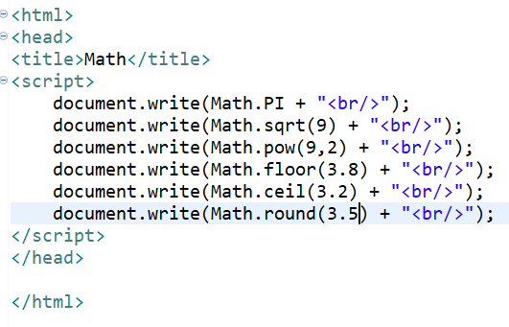

**//output**

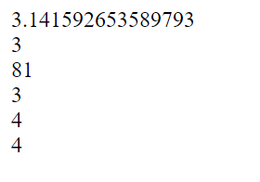

**Arrays**

**Arrays is group of object or different types of object**

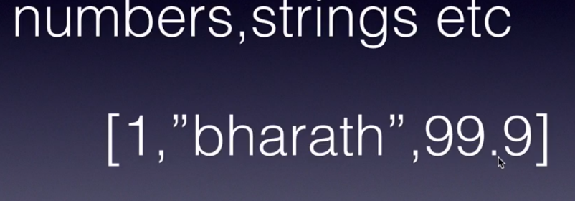

**Different types of creation of array( three ways)**

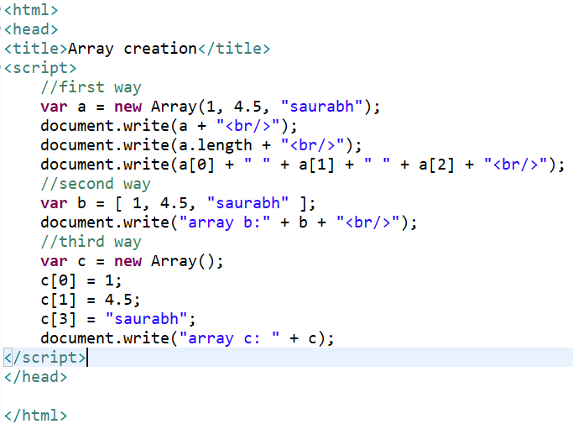

**//output**

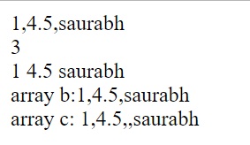

**Concat ,reverse and join function**

**Join will allow to join all element of array with delimiter between element**

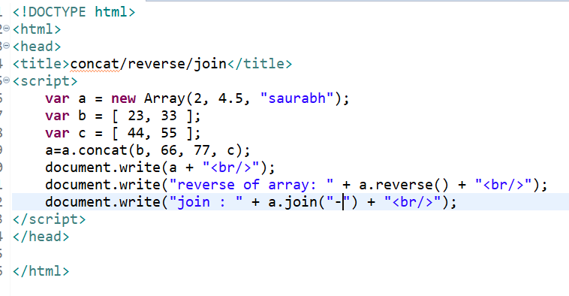

**//output**

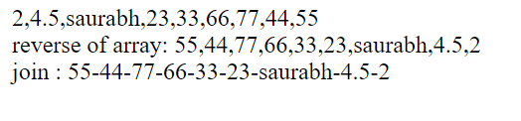

**Delete and replace function**

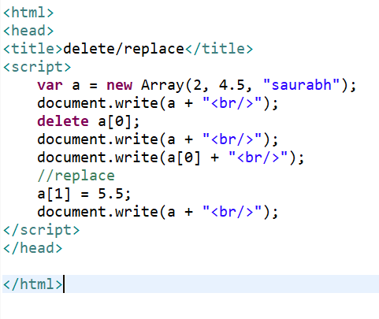

**//output**

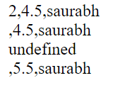

**Date**

**Java script date object give access to system date and time**

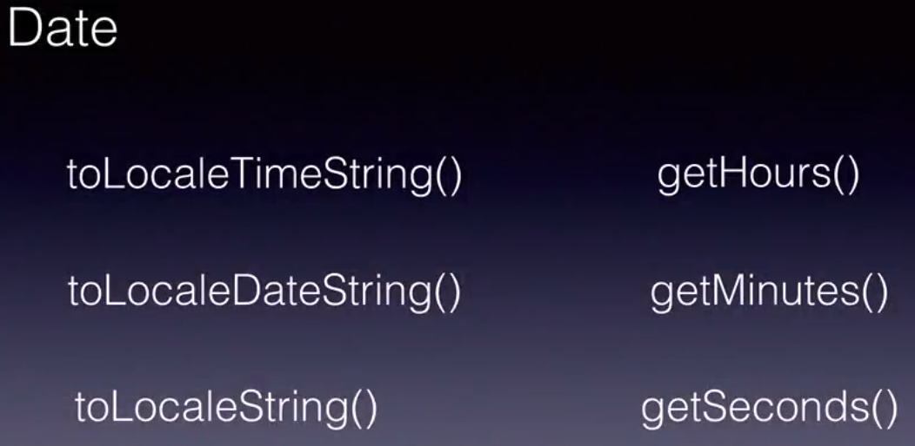

**To manipulate html element we use innerHTML**

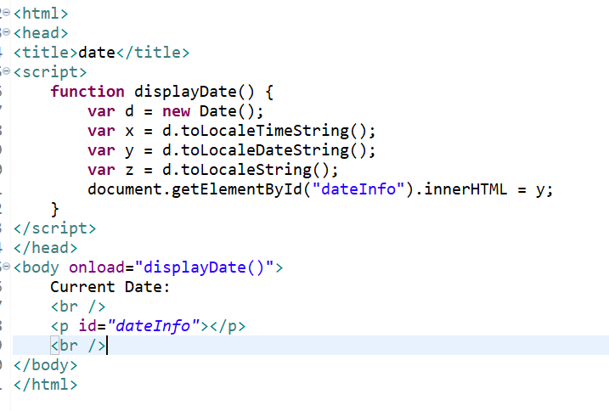

**setInterval method**

**setTimeout method: invoke only once**

**setInterval : invoke a method continously**

**How to continuously update time on web browser**

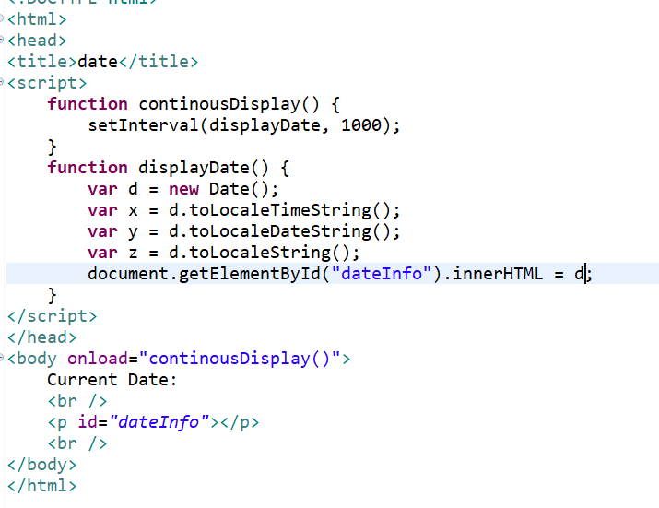

**Section 9 - error handling and debugging**

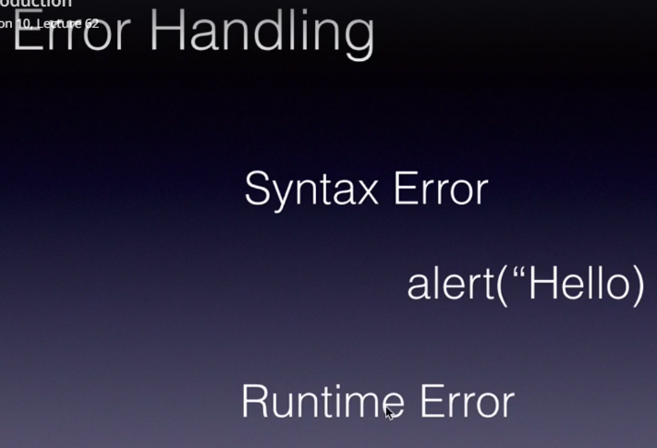

**Runtime error:**

**Example:- if we try to invoke a function that doesn't exist**

**In javascript we use error instead of exception**

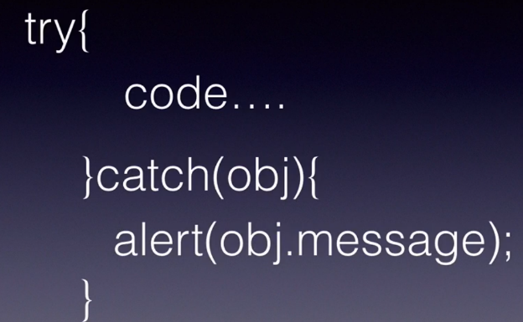

**Invoking a method which does not exist so it will give error and need to handle it using try catch.**

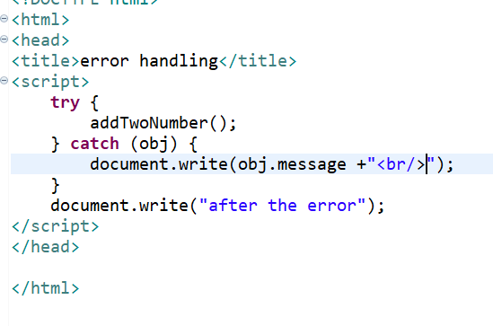

**//output**

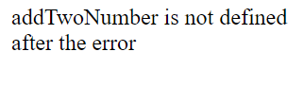

**Throwing custom errors**

**Throw our own custom error and handle them**

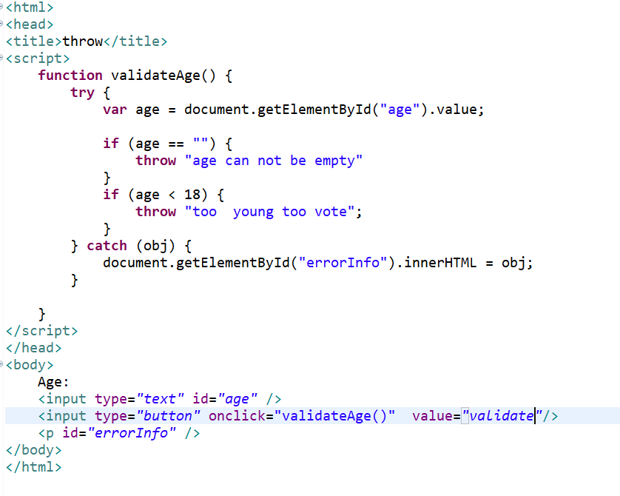

**Finally**

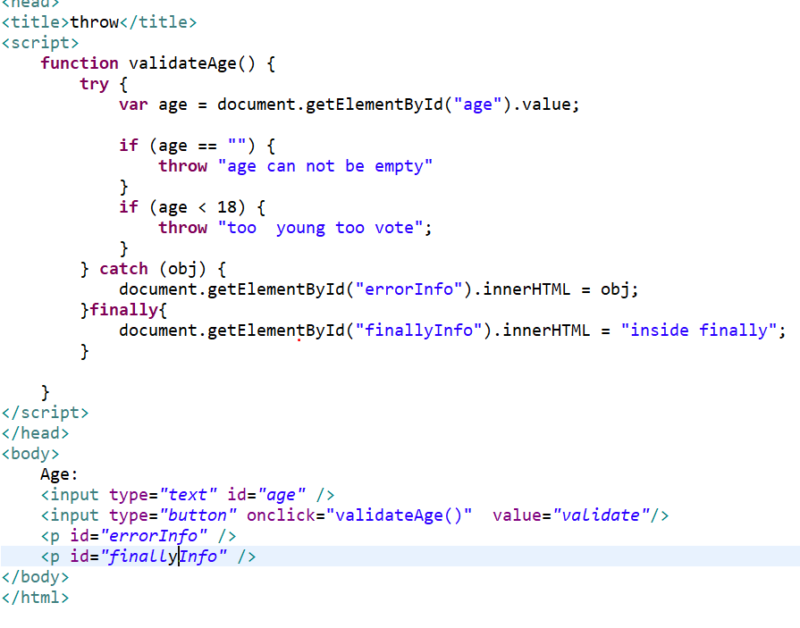

**//output**

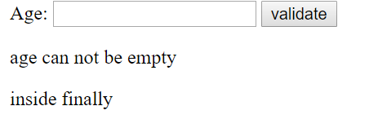

**Section 11) HTML DOM**

**Dom introduction**

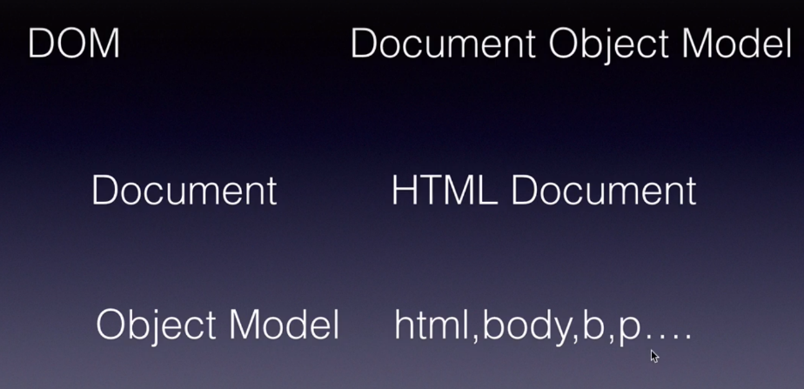

**Document is html document that is loaded into memory**

**We can access html element ,attribute using document object within JS code**

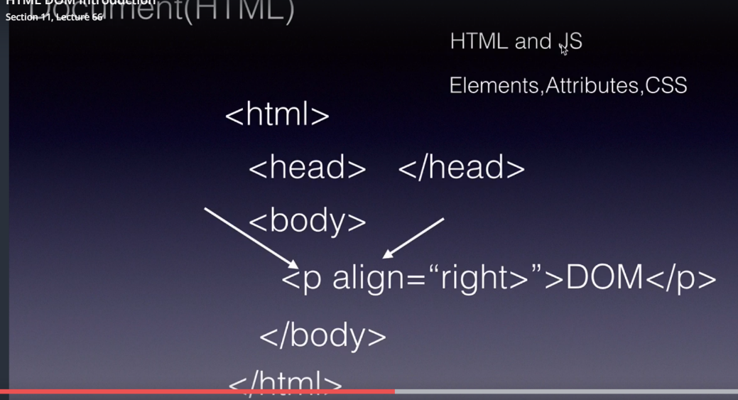

**Example**

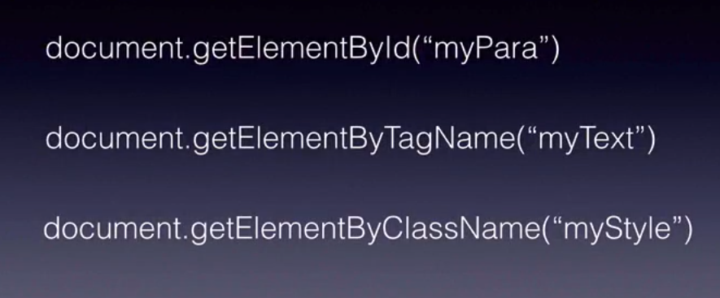

**Access html**

**Para name will appear on center**

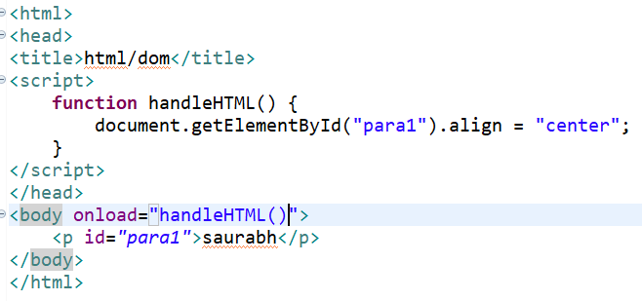

**Access styling information**

**Using dom we can also apply styling to html element**

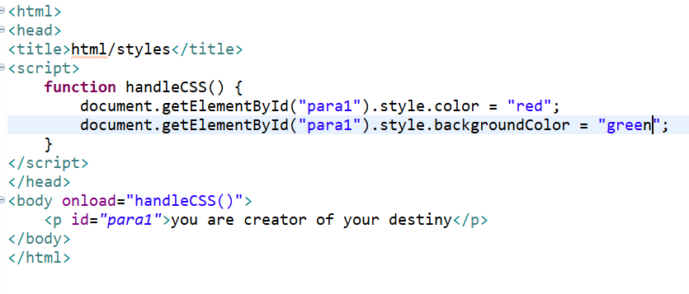

**Event Listener**

**important**

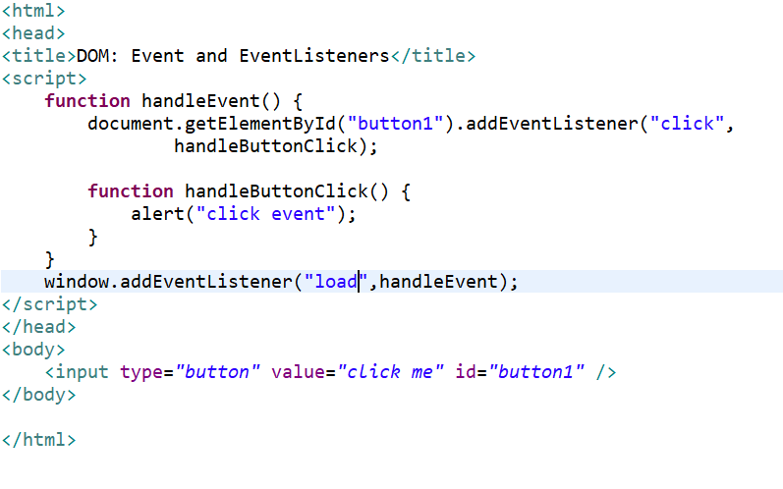

**Remove node**

**Entire html element refer as node.**

**How to dynamically add and remove node from JS function**

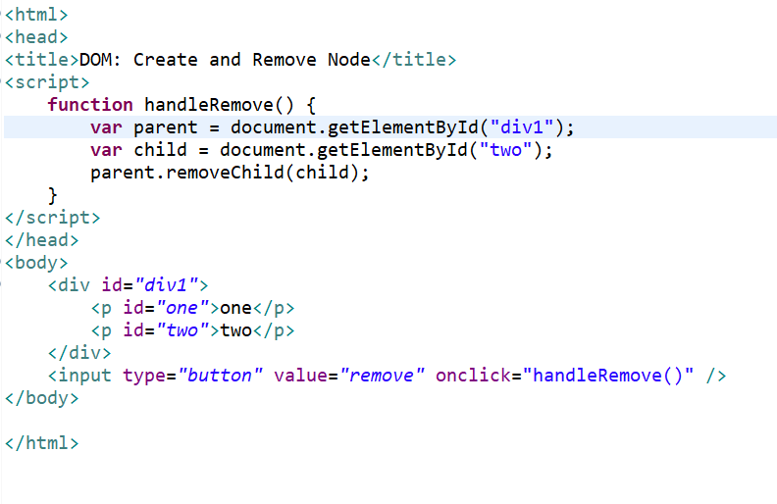

**//output**

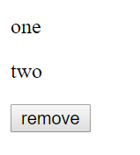

**Create a node**

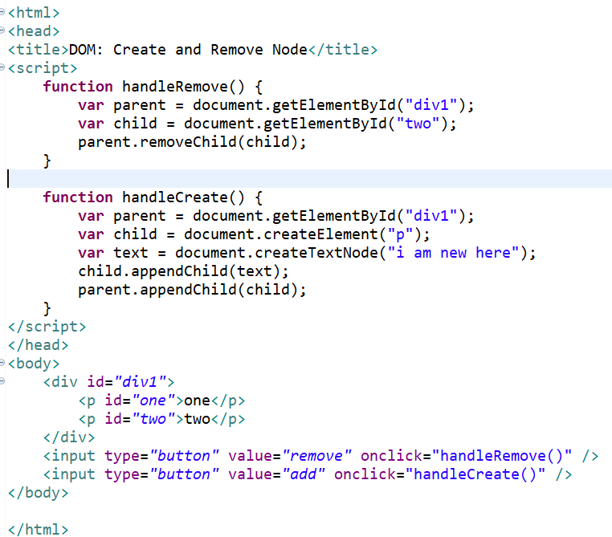

**//output**

